------------------------------------------------------------------------------------------------------------------

------------------------------------------------------------------------------------------------------------------

Public 20.164.1.124   
Private 10.0.0.4

labuser

Cyberrange123

------------------------------------------------------------------------------------------------------------------

------------------------------------------------------------------------------------------------------------------

Tanable - Nessus

Trial License Information

Activation Code:   
Valid until: 2025-06-16

Nessus administrator user account. Use this username and password to log in to Nessus.

TYLONs17

Note: You need a work/school email to get the Tenable Nessus Professional free trial.

------------------------------------------------------------------------------------------------------------------

------------------------------------------------------------------------------------------------------------------

**\*Creating the Azure VM\***

1. Configure the Basics Tab:

- Resource group: Create new > Enter "VulnerabilityManagement"

- Virtual machine name: Enter "josh-vm-lab-00"

- Region: US East 2

- Image: Windows 10 Pro, version 22H2 - x64 Gen2

- Size: Standard D2s v3 (2 vcpus, 8 GiB memory)

- Administrator account: Enter secure credentials

2. Set up remaining tabs:

- Disks Tab: Choose Standard HDD (locally-redundant storage) for OS disk type

- Networking Tab: Enable "Delete public IP and NIC when VM is deleted"

- Monitoring Tab: Disable boot diagnostics

- Review + Create Tab: Proceed with creation

**\*Configure the Windows 10 Environment\***

1. Connect to josh-vm-lab-00 using Remote Desktop Connection with admin credentials and set privacy preferences

2. Immediately pause Windows Update

3. Complete Nessus Professional installation on the virtual machine

4. Configure Windows Defender Firewall:

- Search and open wf.msc

- Navigate to Windows Defender Firewall Properties

- For each profile (Domain, Private, Public):

- Press 'O' key to modify settings (In this case turning off)

- Apply changes and confirm with OK

5. Set up PowerShell configuration: (To allow remote connection)

- Launch PowerShell with administrator privileges

- Execute command:

Set-ItemProperty -Path "HKLM:\SOFTWARE\Microsoft\Windows\CurrentVersion\Policies\System" -Name "LocalAccountTokenFilterPolicy" -Value 1 -Type DWord -Force

6. Perform system restart

**\*Run Scan 1\***

1. Initialize new scan:

- Open Nessus Professional

- Select "Create new scan" > "Advanced Scan"

2. Configure scan settings:

- Name: cyberrange-vulscan-manegement-demo

- Target: josh-vm-lab-00 private IP (10.0.0.4)

- Enable "Use fast network discovery" under Host Discovery

3. Set up credentials:

- Navigate to Credentials tab > Windows

- Input josh-vm-lab-00 admin credentials

- Did not enter anything under the Domain option

4. Enable required services:

- Start the Remote Registry service during the scan

- Enable administrative shares during the scan

- Start the Server service during the scan

5. Begin scan execution

????????????????????????????????????????

*MY SCAN TOOK LESS THAN A MINUTE THEY DID NOT WORK (16 secs)***SCAN TROUBLESHOOTING STEP**

**See** **TROUBLESHOOTS**

????????????????????????????????????????

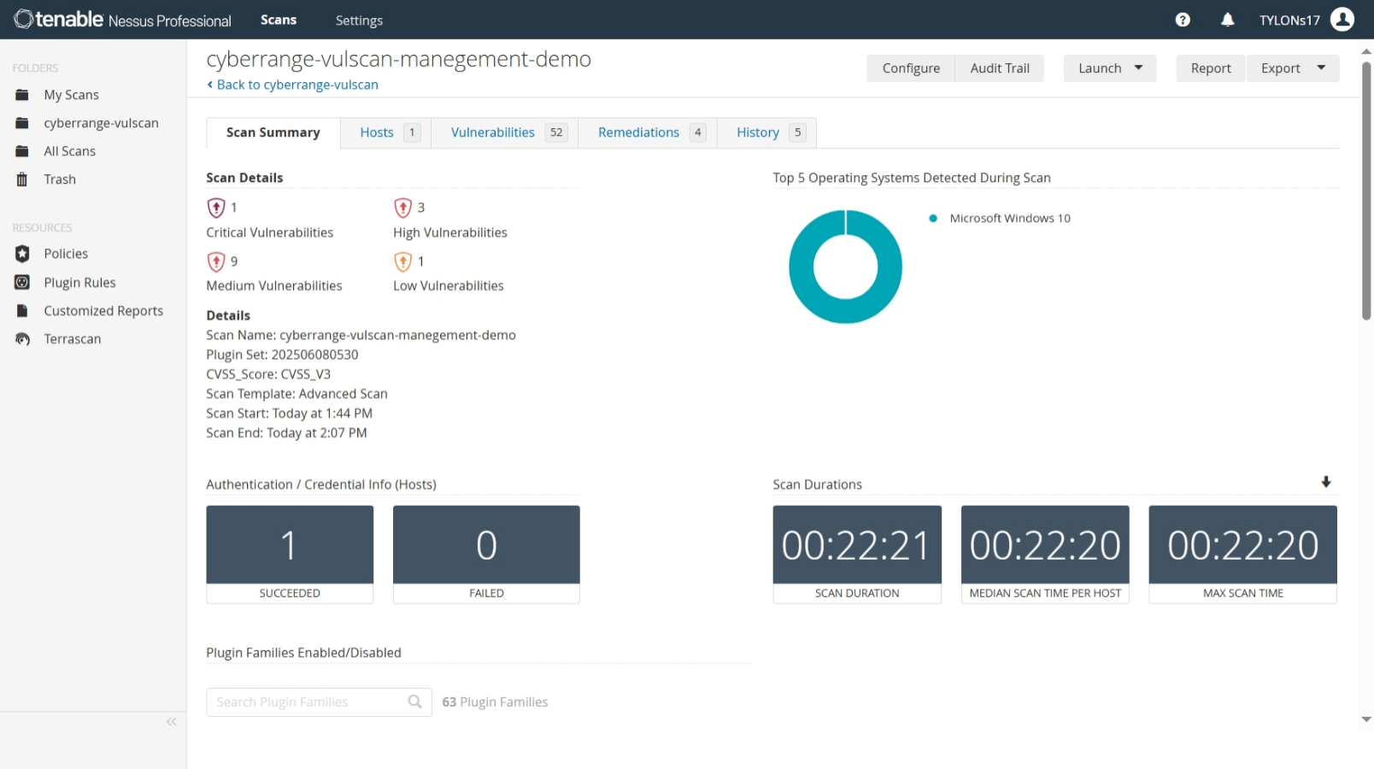

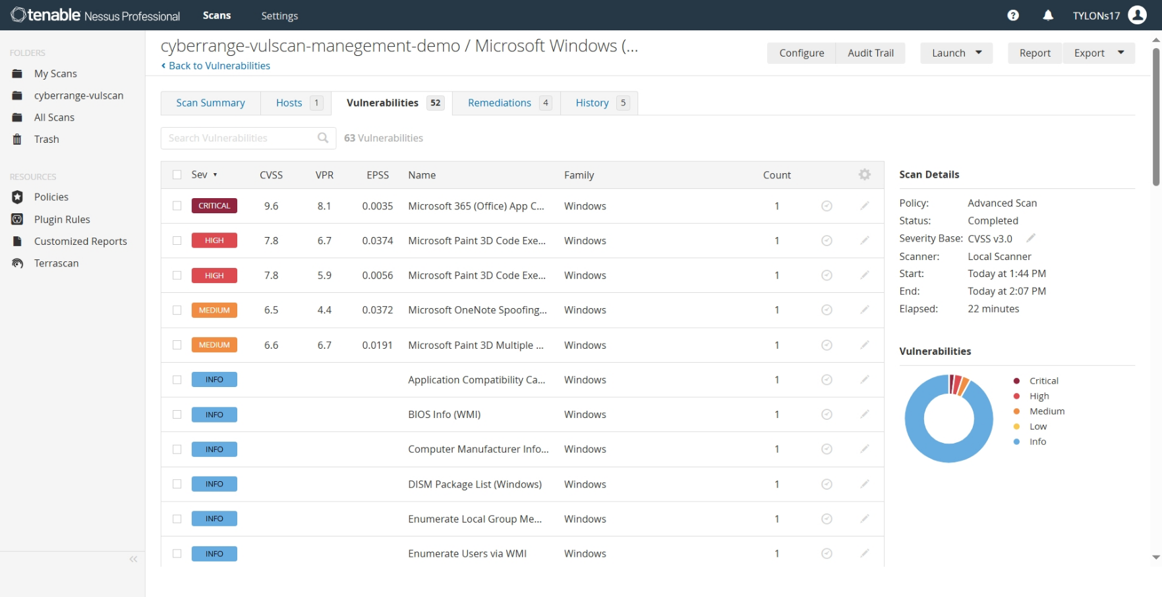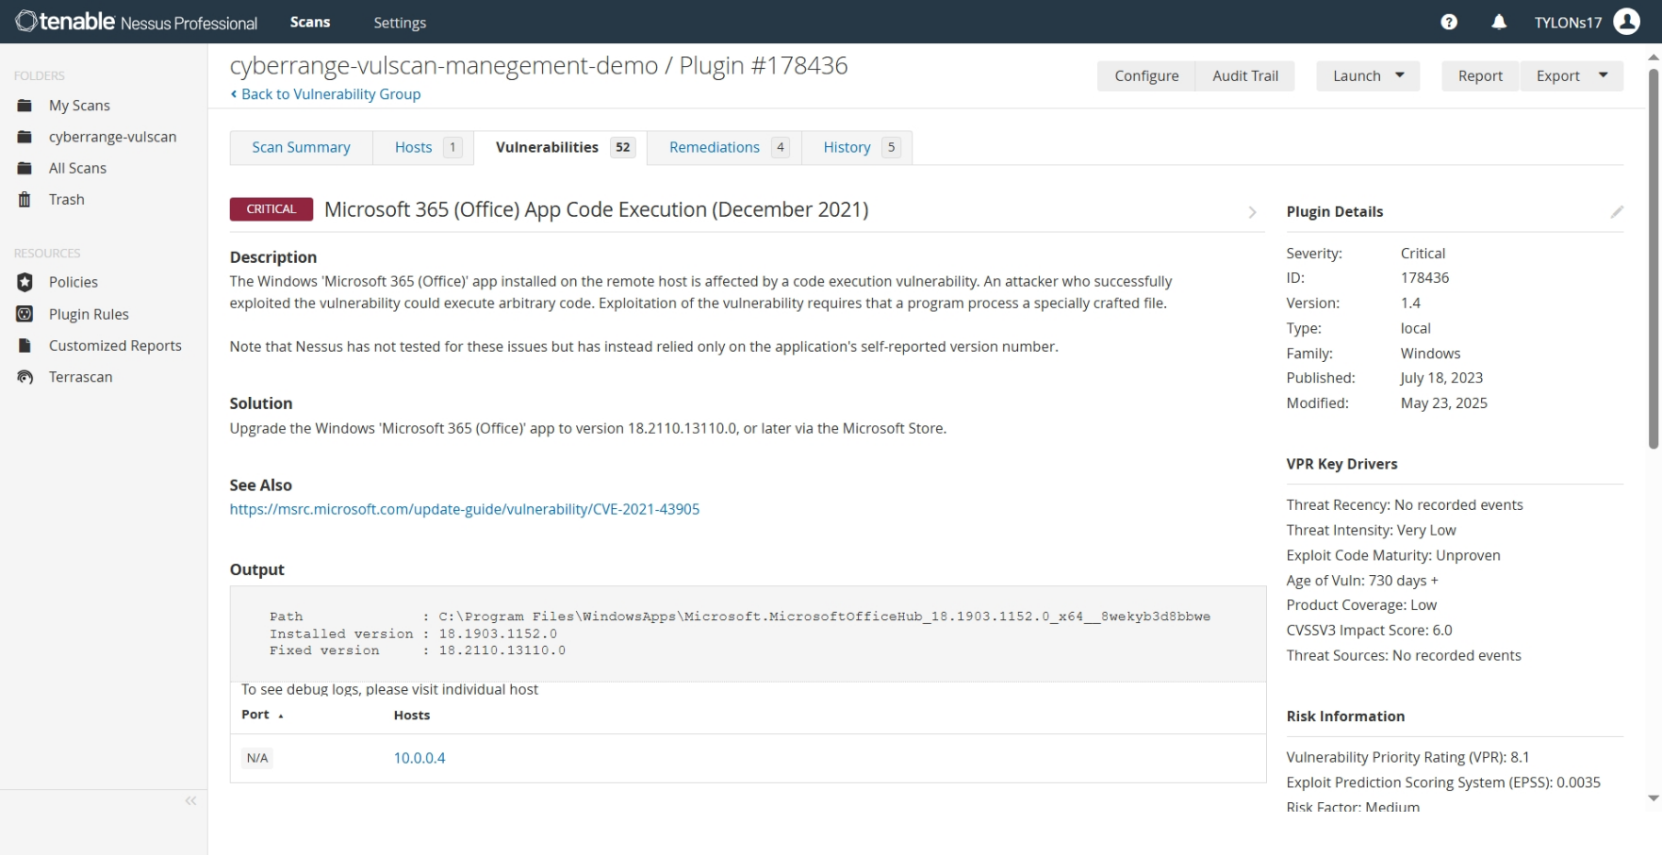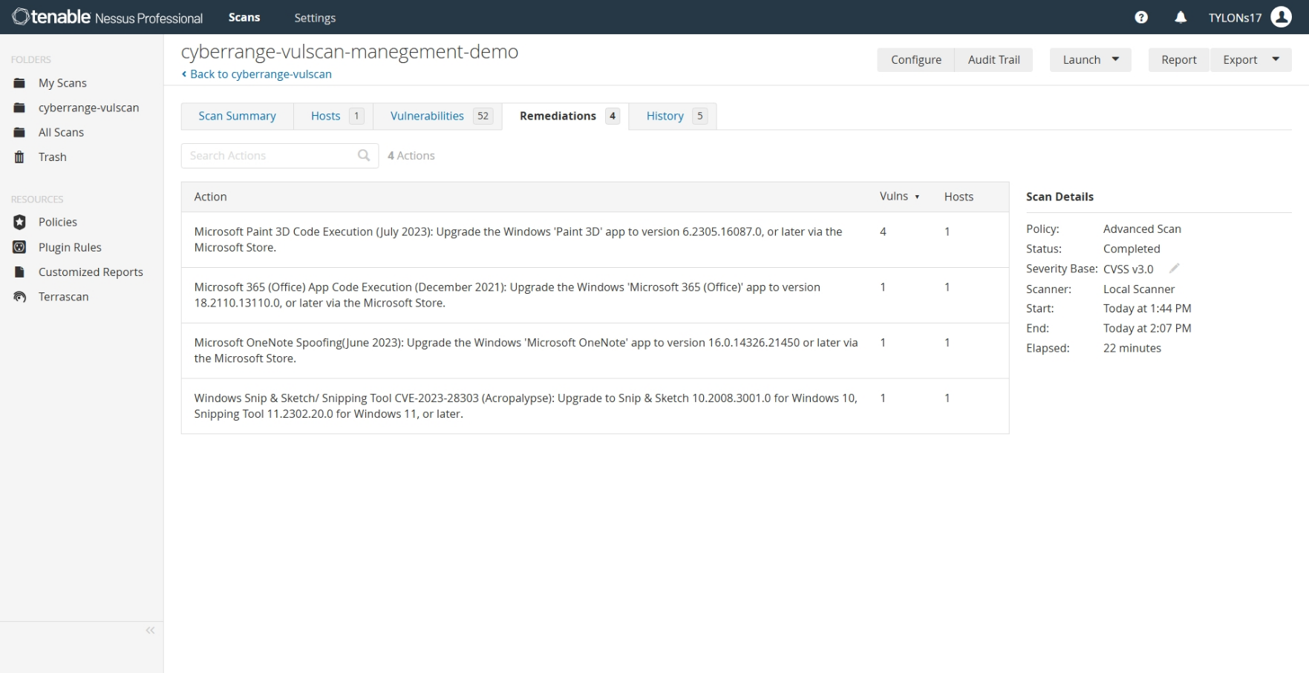

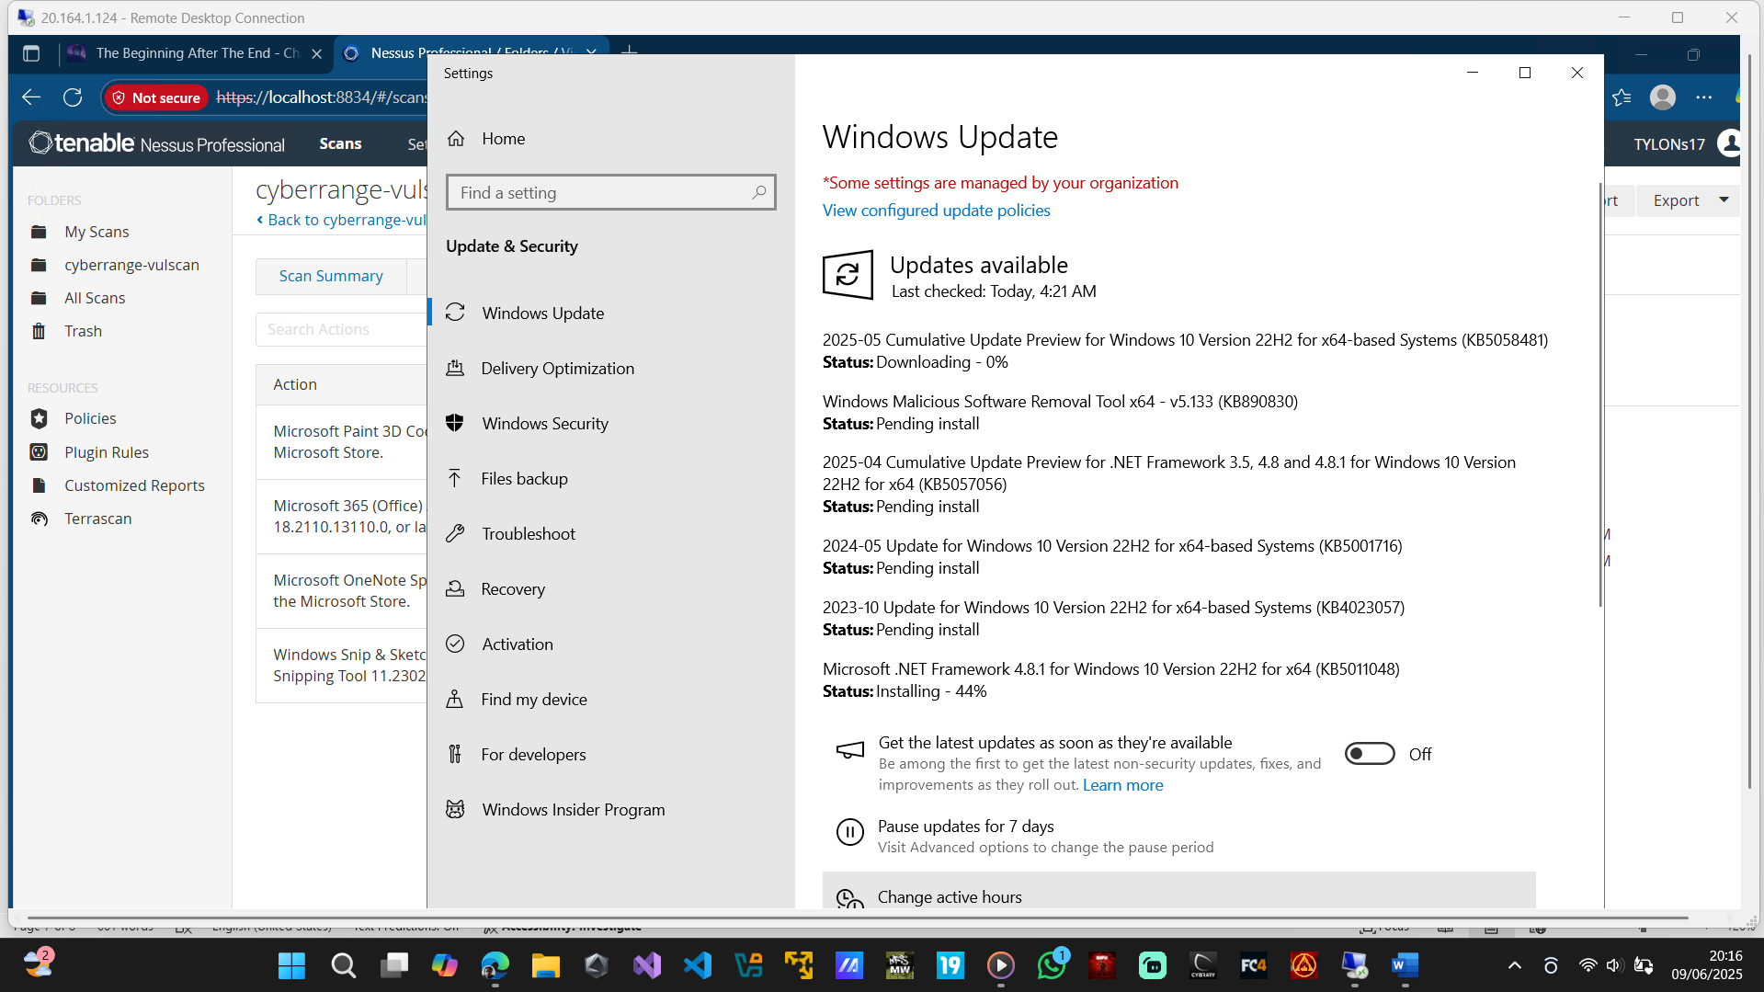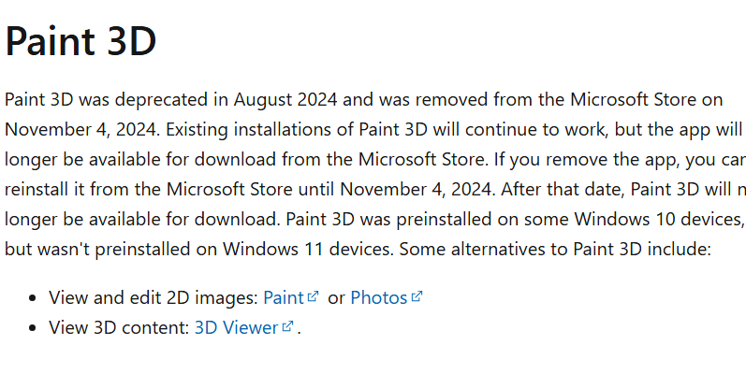

**\*Make Virtual Machine Vulnerable\***

1. Install Firefox version 110 https://ftp.mozilla.org/pub/firefox/releases/110.0/win64/uk/Firefox%20Setup%20110.0.exe
2. Enabled the guest account in   
   Start > scomputer management > Local users and groups >Users > Guest > uncheck “account is disabled”
3. Enable SMBv1 Support (Insecure Protocol)  
   Start > turn windows features on or off > SMB 1.0/CIFS File Share Support

**\*Run Scan 2\***

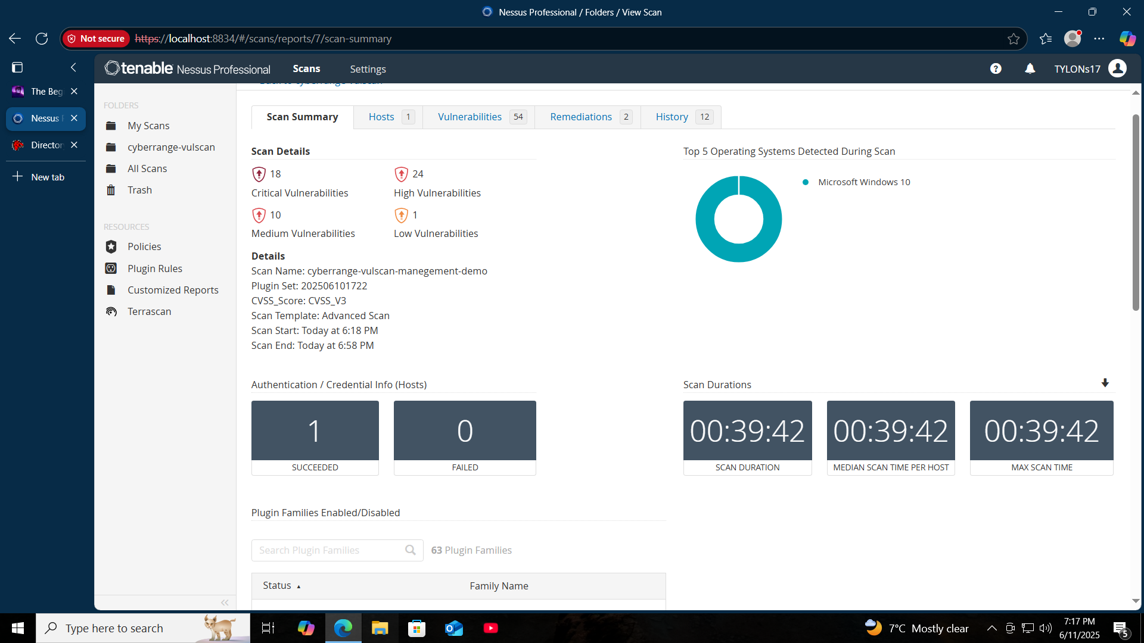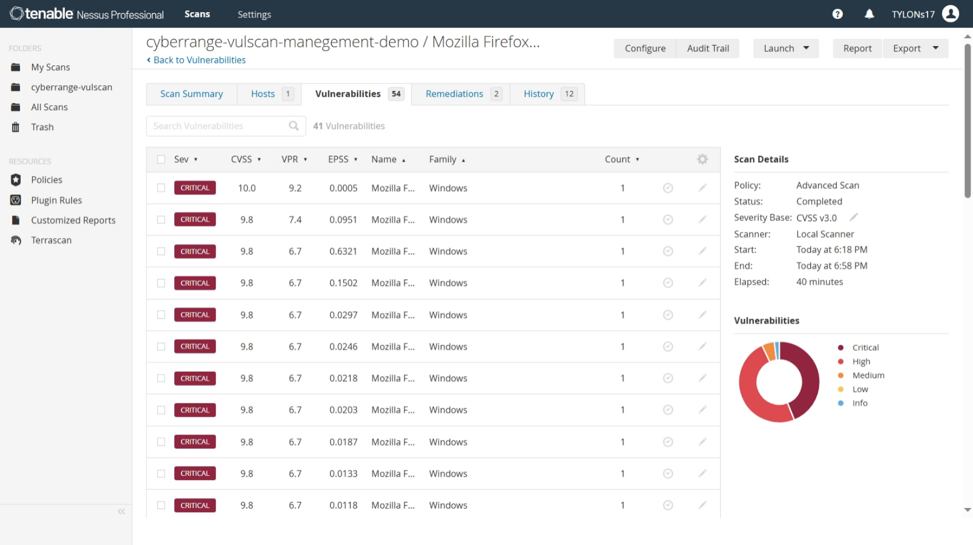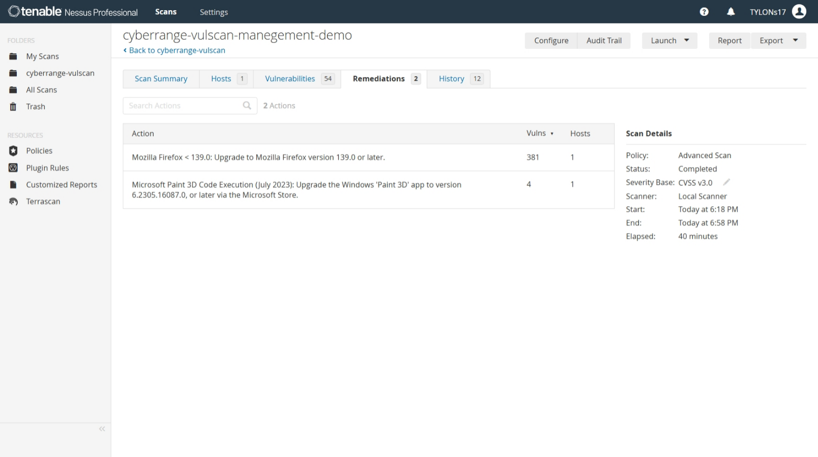

**\*Remediate the System\***

1. Remove vulnerable components:
   * Uninstall Firefox v110:
2. Disable the Guest Account:
3. Disable SMB 1.0/CIFS File Share Support:
4. Install secure software (optional):
   * Download latest Firefox from Mozilla:
   * Enable automatic updates

**\*Run Scan 3\***

Perform final vulnerability assessment  
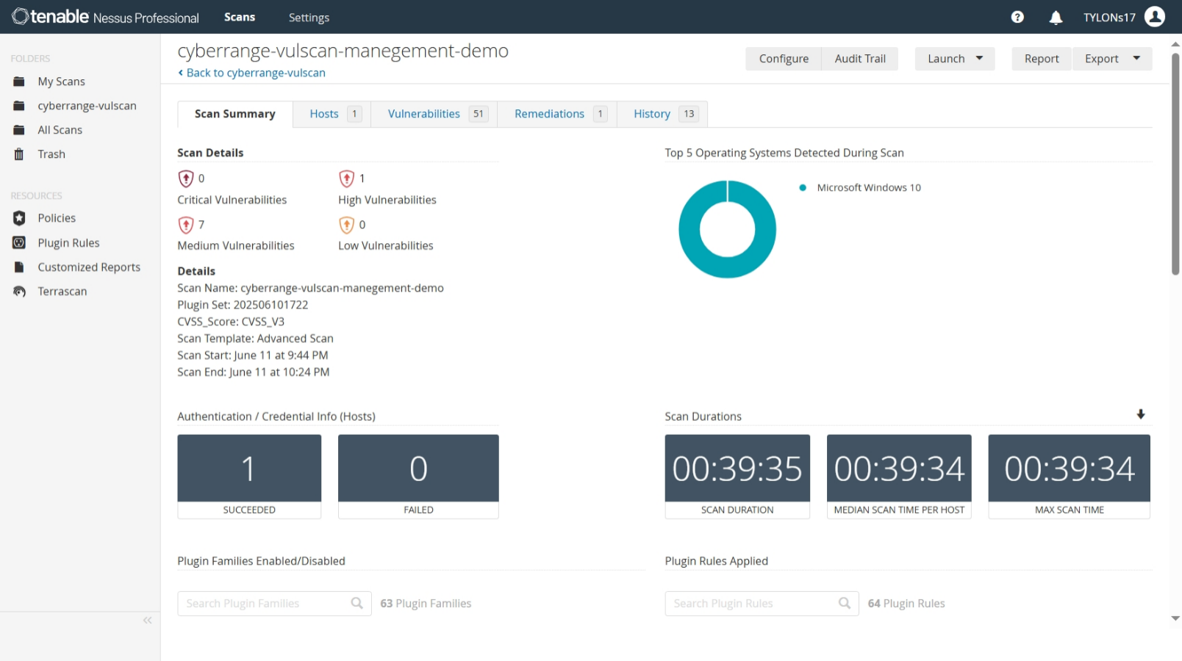

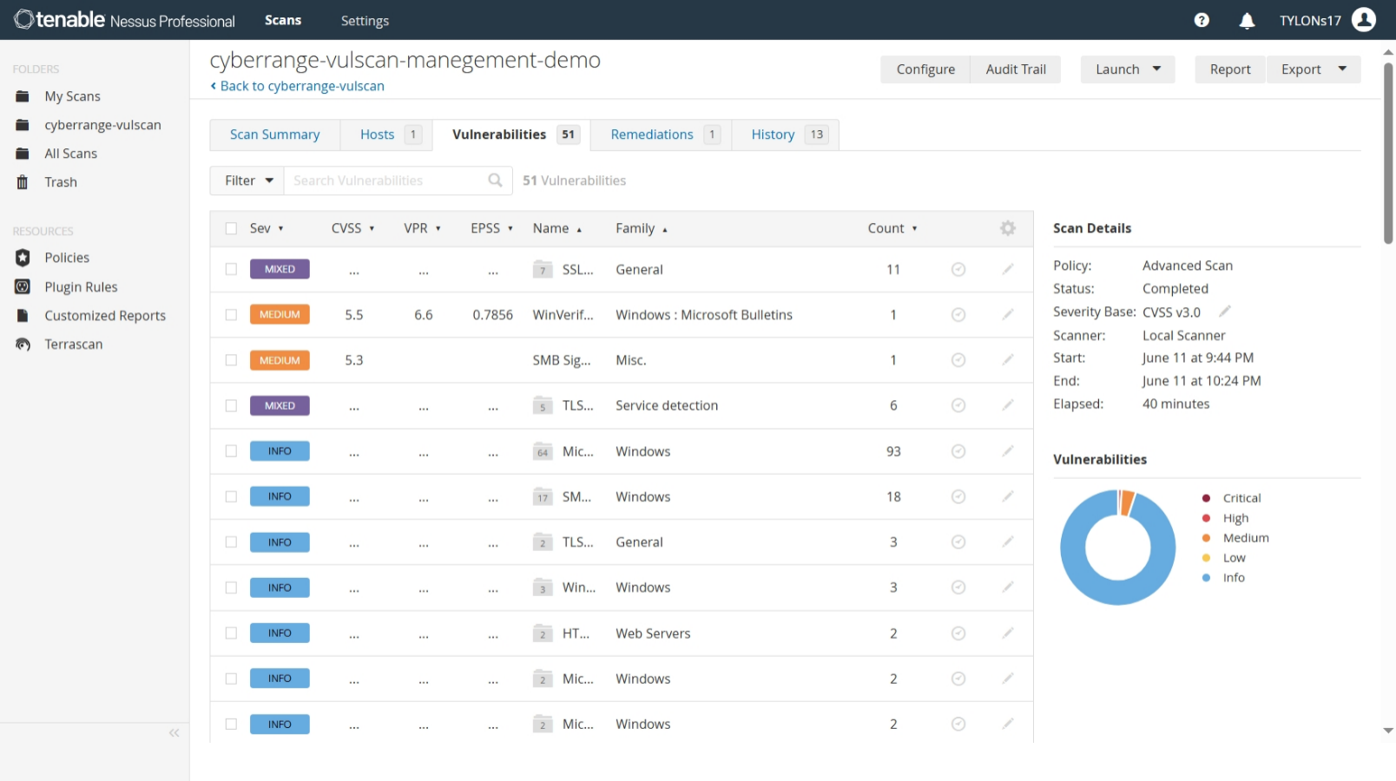

**\*Create Data Visualization of the 3 Scans\***

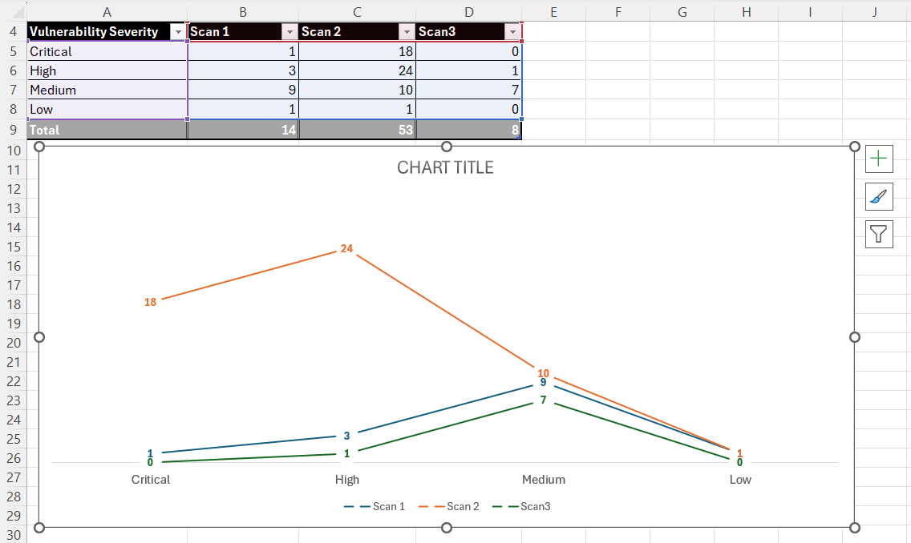

**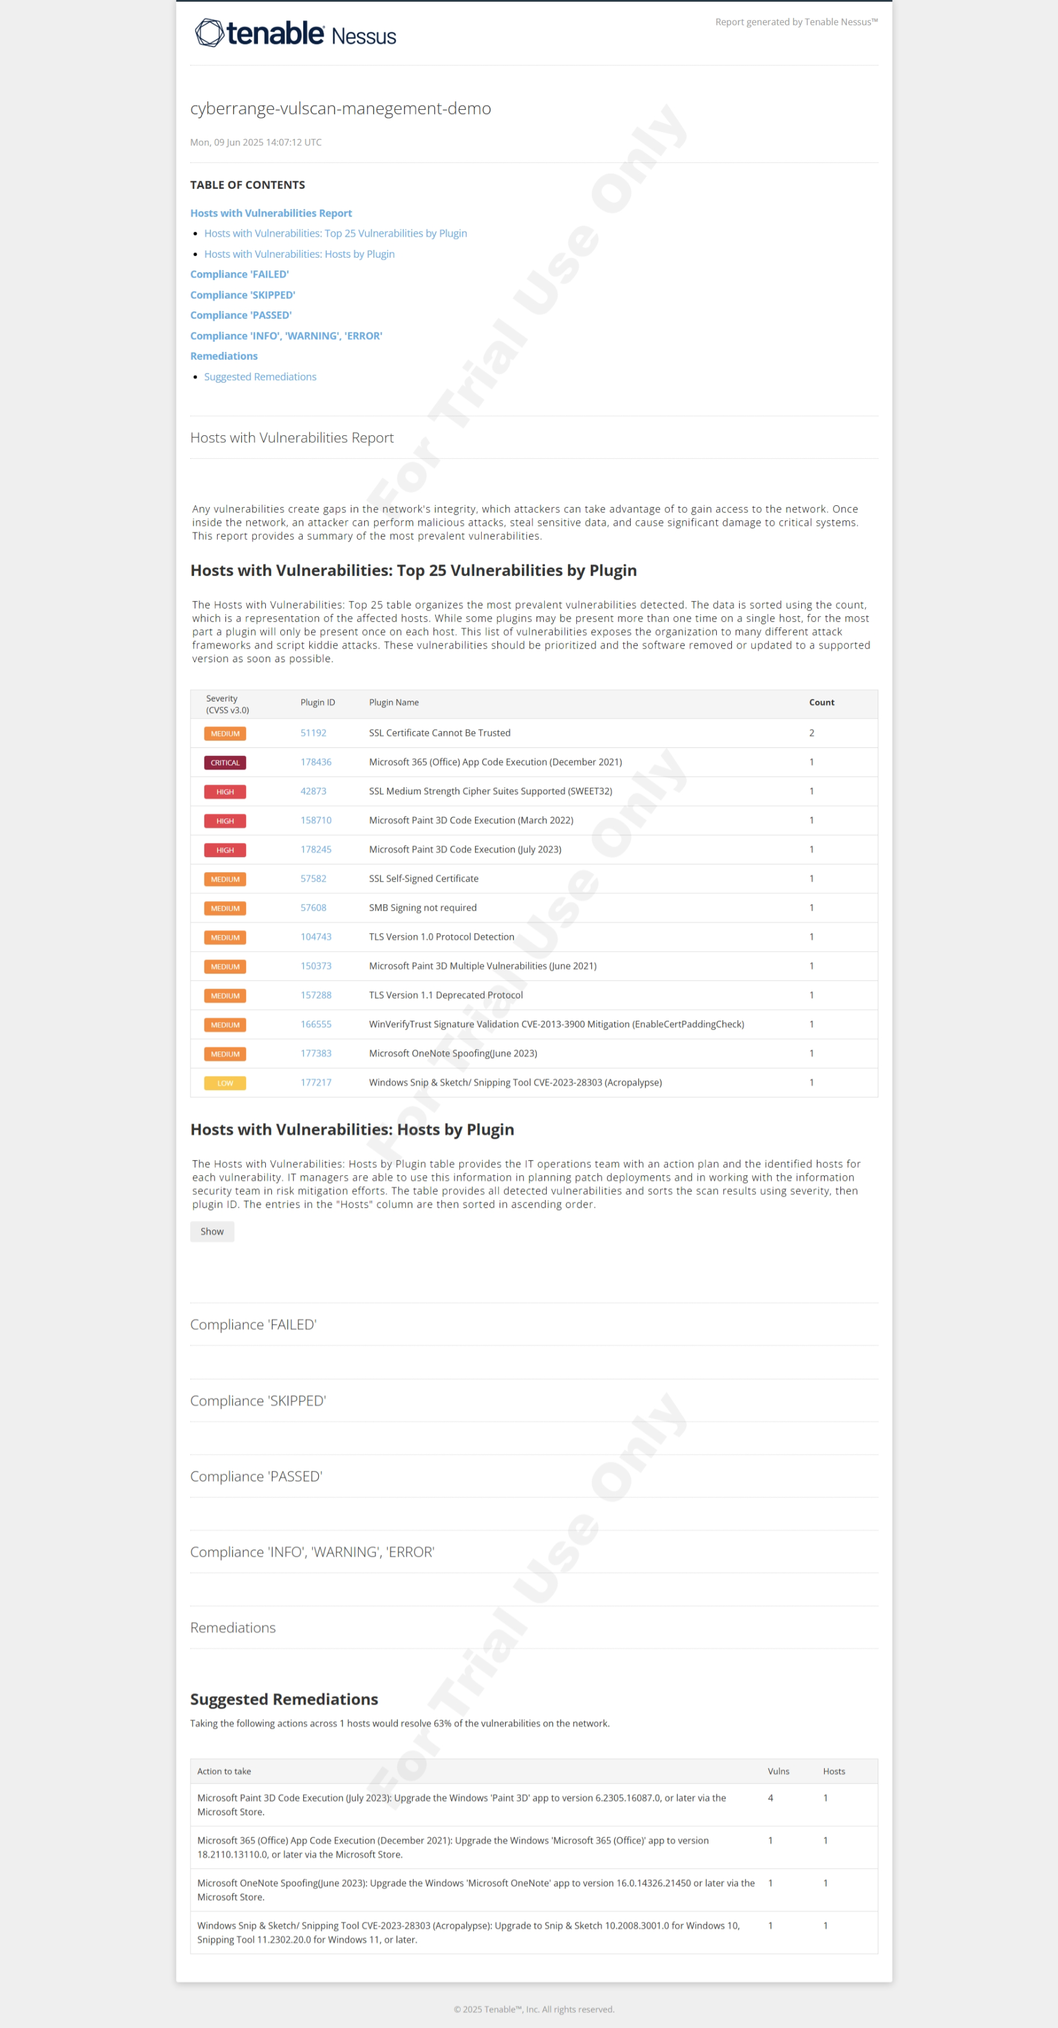  
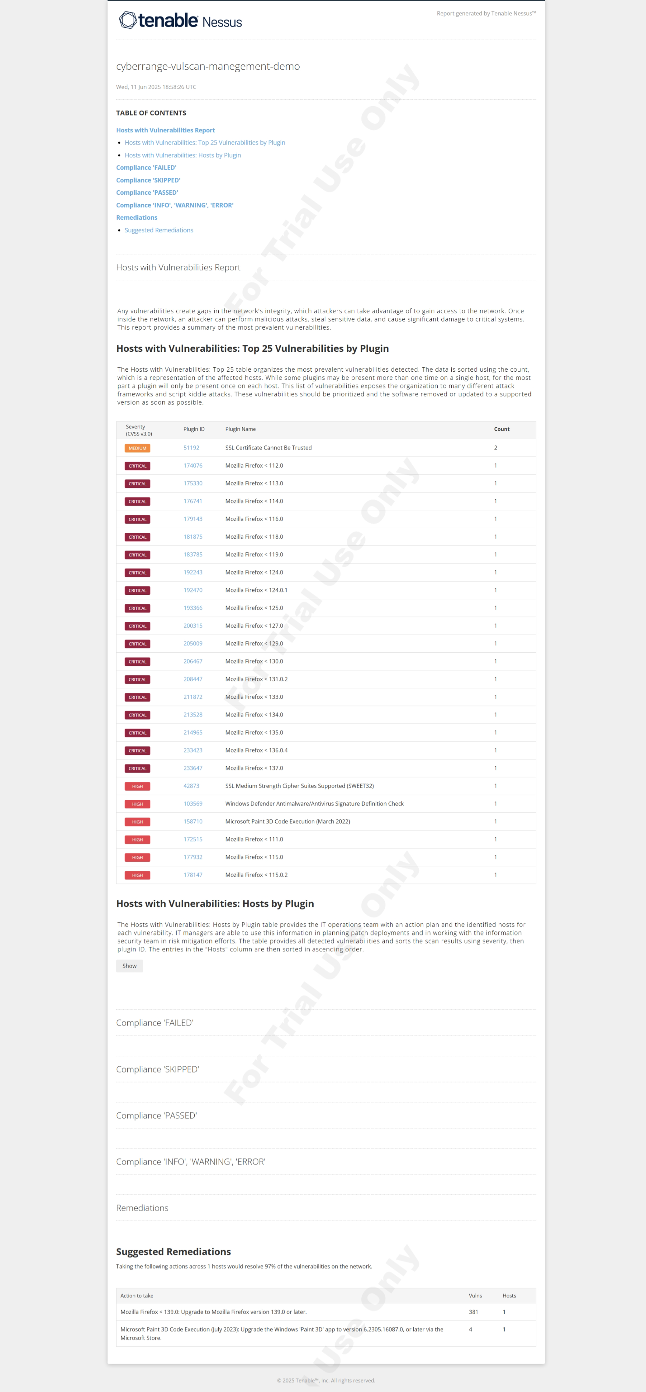**

Scan 1

Scan 1

Scan 2

Scan 2

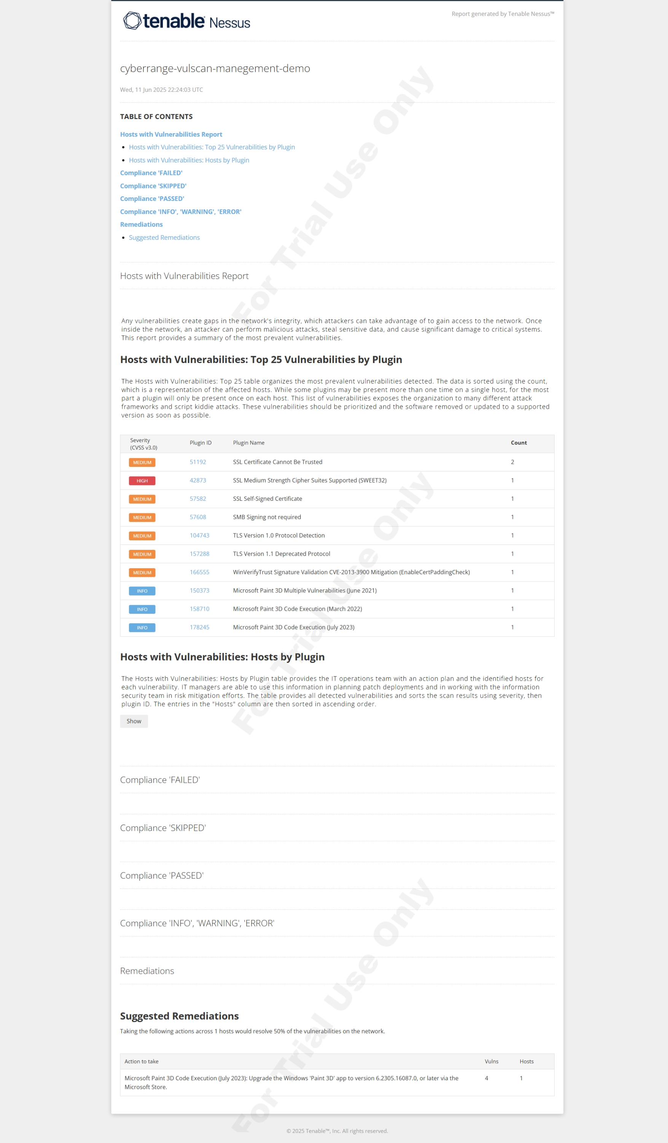

Scan 3

Scan 3

# ***TROUBLESHOOTS***

??????????????????????????????????????????????????????????????

*SCAN TOOK LESS THAN A MINUTE THEY DID NOT WORK (16 secs)***SCAN TROUBLESHOOTING STEP**

????????????????????????????????????????

Asked AI about possible causes

**⚠️⚠️⚠️⚠️⚠️⚠️⚠️⚠️⚠️⚠️⚠️⚠️⚠️⚠️⚠️⚠️⚠️⚠️**

Misconfigured my IP :"Target: josh-vm-lab-00 private IP (20.164.1.124 - I used the public ip hence the problem)".

Action: **Change the target in your Nessus scan configuration to 10.0.0.4 or 127.0.0.1.** This ensures the scan is trying to access the local machine correctly.

**⚠️⚠️⚠️⚠️⚠️⚠️⚠️⚠️⚠️⚠️**

IF RUNNING NESSUS SCAN EXTERNALLY (not on the vm machine) found out it was due to an NSG inbound rule that denies all inbound traffic (Need to add new rule to allow our allow Nessus scan with priority 110 comes before priority 65500 Deny all rule)

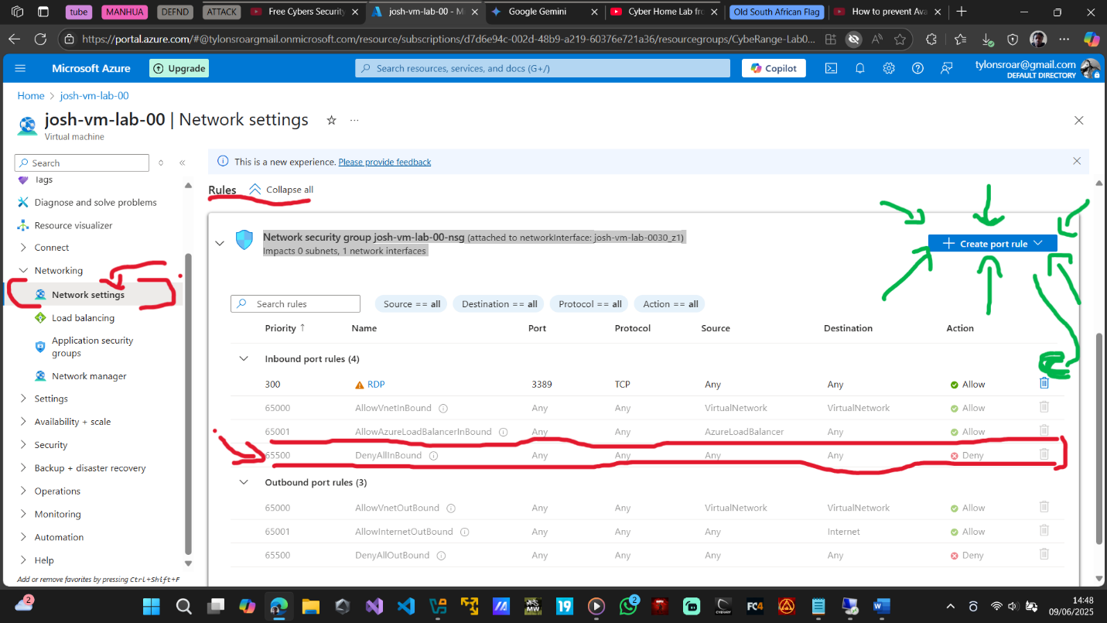

Example Inbound Rule Configuration (Using Azure Portal):

**Source**: If your Nessus scanner has a fixed IP, enter that specific IP address. If the Nessus scanner is in Azure, you can specify the Nessus VM's private IP. If the Nessus scanner is external to Azure, you may need to use its public IP (less secure for production).  
**Source Port Ranges:** * (any)  
**Destination:** The private IP address of josh-vm-lab-00 (e.g., 20.164.1.124 if that's the private IP, but double-check in the Azure portal).  
**Destination Port Ranges:** The specific port (e.g., 135) or port range (e.g., 49152-65535).  
**Protocol:** TCP

**Action:** Allow

**Priority:** A number lower than 65500 (e.g., 100).

**Name:** A descriptive name (e.g., AllowNessus135).